

ROSTER – February 28, 2021 at Oakland

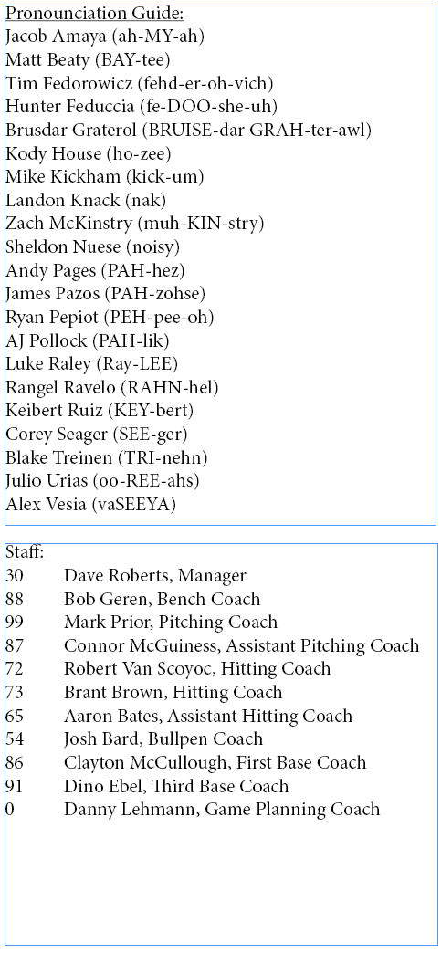
Starting Lineup:
50 Mookie Betts RF
5 Corey Seager (L) SS
15 Austin Barnes C
11 AJ Pollock LF
45 Matt Beaty (L) 1B
43 Edwin Ríos (L) 3B
57 Matt Davidson DH
8 Zach McKinstry (L) 2B
70 DJ Peters CF
59 Mike Kickham LHP

Pitchers:
61 Garrett Cleavinger LHP
77 Dennis Santana RHP
78 Michael Grove RHP*
92 Edwin Uceta RHP*
94 Andre Jackson RHP

Catchers:
18 Tim Federowicz*
79 Hunter Feduccia (L)*

Infielders:
52 Jacob Amaya*
56 Sheldon Neuse
58 Michael Busch (L)*

Outfielders:
62 Luke Raley (L)
84 Zach Reks (L)
95 Andy Pages*
97 James Outman

* Non-Roster Invitee

