

ROSTER – February 28, 2021 at Oakland

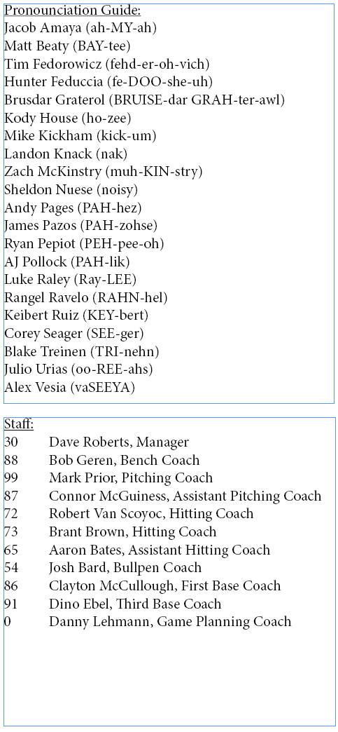Starting Lineup:

50 Mookie Betts RF

5 Corey Seager (L) SS

15 Austin Barnes C

11 AJ Pollock LF

45 Matt Beaty (L) 1B

43 Edwin Ríos (L) 3B

57 Matt Davidson DH

8 Zach McKinstry (L) 2B

70 DJ Peters CF

59 Mike Kickham LHP

­Pitchers:

61 Garrett Cleavinger LHP

77 Dennis Santana RHP

78 Michael Grove RHP\*

92 Edwin Uceta RHP\*

94 Andre Jackson RHP

Catchers:

18 Tim Federowicz\*

79 Hunter Feduccia (L)\*

Infielders:

52 Jacob Amaya\*

56 Sheldon Neuse

58 Michael Busch (L)\*

Outfielders:

62 Luke Raley (L)

84 Zach Reks (L)

95 Andy Pages\*

97 James Outman

\* Non-Roster Invitee